**Homework 11 Suggested Solution**

1. Sheila is endowed with 8 pounds of coffee (x-good) and 16 quarts of milk (y-good) and Bruce is endowed with 4 pounds of coffee and 16 quarts of milk. We can represent Sheila’s and Bruce’s preferences over coffee (x) and milk (y) by the following utility functions:

**US = xSyS** and **UB = xB (yB)2**

1. Draw an Edgeworth box diagram illustrating the feasible allocations.

Sheila

Bruce

(8, 16)

(4, 16)

32 quarts of milk

1. Is the endowment a Pareto efficient allocation? Illustrate a pair of indifference curves (one each for Sheila and Bruce) through the endowment point in your diagram in part (a).

Answer:

at (8, 16),

 at (4, 16)

Since the MRS of Sheila and Bruce are the same at the endowment bundle, it is a Pareto efficient allocation.

Suppose that we set up a market for each of the goods and that Bruce and Sheila are price takers in each of these markets. They are free to buy and sell goods at the same prices in these markets.

1. Define the general equilibrium price vector (i.e. the GE pair of prices) for this market economy. Find one pair of prices such that both markets clear and Sheila and Bruce each choose to consume their own individual endowment (i.e. neither buys or sells any goods).

Define , the market clears and both Bruce and Sheila purchase their own endowment means *MRSS* = *MRSB* = *P* at (8, 16) for Sheila and (4, 16) for Bruce. Therefore *P* = 2. Any combination of *Px*= 2*Py* satisfies the requirement.

1. An allocation in an exchange economy is called ***envy free*** if each individual prefers his or her own allocation of goods to the allocation received by any other individual. Show that the endowment in this example is not envy free.

*US*(4, 16) = 64 < *US*(8, 16) = 128. Sheila won’t envy Bruce.

However, *UB*(8, 16) = 2,048 > *UB*(4, 16) = 1,024, Bruce prefers Sheila’s endowment over his.

The endowment is not envy free.

1. Given your answers to c and d can you conclude that an allocation of goods associated with a general equilibrium of a market economy are envy free?

No, a general equilibrium allocation is not necessary envy free.

2. Sheila and Bruce are going to the movies. Sheila is bringing 20 ounces of soda (x) and 8 ounces of chocolate (y). Bruce is bringing 10 ounces of soda and 12 ounces of chocolate. Sheila‘s and Bruce’s preferences over soda and chocolate can be represented by the utility functions:

US(xS,yS) = 27**ln**xS + 7**ln**yS and UB(xB,yB) = 6**ln**xB + **ln**yB.

1. Is the endowment point Pareto efficient? Illustrate in an Edgeworth box diagram the endowment point and a pair of indifference curves through the endowment point.

**MRSs = 27ys/7xs = 1.54 at (20, 8)**

**MRSb = 6yb/xb = 7.2 at (10, 12)**

XS

YS

YB

XB

8

12

10

20

Bruce

Sheila

Soda

Chocolate

Instead of trading directly with each other Sheila and Bruce trade with a market. Sheila and Bruce are both price takers on both the soda and chocolate markets. Each can buy and sell a good at the same price. Let Px be the price of an ounce of soda and Py be the price of an ounce of chocolate.

1. Write the two equations that define the best bundle for Sheila given that the prices are Px and Py. Do the same for Bruce.

**Sheila’s tangency: ys = 7Pxs/27**

**Sheila’s feasibility: Pxs + ys = 20P + 8**

**Bruce’s tangency: yb = Pxb/6**

**Bruce’s feasibility: Pxb + yb = 10P + 12**

1. Suppose that the price of soda (Px) is equal to 13 cents and that the price of chocolate (Py) is equal to 10 cents. Given the MRS’s that you found in part (a) explain why these prices could not represent a general equilibrium pair of prices.

# From part a), the two MRSs are 1.54 and 7.2. They would equalize somewhere in between 1.54 and 7.2 and hence the GE price ratio must be greater than 1.54 and less than 7.2. Any price ratio outside of that range would not achieve both:

1. **mutually beneficial trading and**
2. **clear both markets**
3. Using your answer for part (b) find Sheila’s best bundle when Px = 13 and Py = 10. Is Sheila a net demander or a net supplier of chocolate (y)? Find Bruce’s best bundle at the same prices. Is Bruce a net demander or supplier of chocolate?

**Plugging in Sheila’s tangency condition into her feasibility condition, we get:**

**34Pxs = 540P + 216. Next, plugging in P = 1.3, we find that xs = 20.77, ys = 7.**

**Plugging in Bruce’s tangency condition into his feasibility condition, we get:**

**7Pxb = 60P + 72. Next, plugging in P = 1.3, we find that xb = 16.48, yb = 3.57.**

**Sheila went from (20, 8) to (20.77, 7), hence she is a net demander of soda (x).**

**Bruce went from (10, 12) to (16.48, 3.57), hence he is also a net demander of soda (x). Clearly, it would not be possible a trade to exist that would satisfy both (hence this is consistent with our argument in part c, that P = 1.3 could not be a GE price vector).**

1. Using your answer for part (d) show that when Px = 13 and Py = 10 neither market clears. Which market has excess supply? Which market has excess demand? Illustrate the budget line associated with these prices in your diagram for part (a).

**Market clearing condition for soda: xs + xb = 30**

**Plugging in solution from part d: 20.77 + 16.48 > 30**

**Market clearing condition for chocolate: ys + yb = 20**

**Plugging in solution from part d: 7 + 3.47 < 20**

**The market for soda has excess demand and the market for chocolate has excess supply.**

1. Using your answer from part (b) show that if Px = 3 and Py = 1 then both markets clear.

**Plugging in Sheila’s tangency condition into her feasibility condition, we get:**

**34Pxs = 540P + 216. Next, plugging in P = 3, we find that xs = 18, ys = 14.**

**Plugging in Bruce’s tangency condition into his feasibility condition, we get:**

**7Pxb = 60P + 72. Next, plugging in P = 3, we find that xb = 12, yb = 6.**

**Market clearing condition for soda: xs + xb = 30**

**Plugging in solution from part f: 18 + 12 = 30**

**Market clearing condition for chocolate: ys + yb = 20**

**Plugging in solution from part f: 14 + 6 = 20**

1. Illustrate the budget line associated with the general equilibrium prices in your diagram in part (a).

3. Sheila and Bruce are having a tea party. Sheila is bringing 30 ounces of tea (x) and 33 finger sandwiches (y). Bruce is bringing 36 ounces of tea and 12 finger sandwiches. Sheila’s and Bruce’s preferences over tea and sandwiches can be represented by the utility functions:

US(xS,yS) = 2**ln**xS + **ln**yS and UB(xB,yB) = **ln**xB + **ln**yB.

1. Is the endowment point Pareto efficient? Illustrate the endowment point and a pair of indifference curves through the endowment point in an Edgeworth box diagram.

**at (30, 33), *MRSS*= 2*yS*/ *xS* = 11/5**

**at (36, 12), *MRSB* = *yB*/ *xB* = 1/3**

**Since the MRS of Sheila and Bruce are not the same at the endowment bundle it is NOT a Pareto efficient allocation.**



Instead of trading directly with each other Sheila and Bruce trade with a market. Sheila and Bruce are both price takers on both the tea and sandwich markets. Each can buy and sell a good at the same price. Let Px be the price of an ounce of tea and Py be the price of a sandwich.

1. Write the two equations that define the best bundle for Sheila given that the prices are Px and Py. Do the same for Bruce.

**Sheila’s tangency: 2yS/ xS = Px/ Py**

**Sheila’s feasibility: Pxxs + Pyys = 30Px + 33Py**

**Bruce’s tangency: yB/ xB = Px/ Py**

**Bruce’s feasibility: Px xB + Py yB = 36Px + 12Py**

1. Show that the price ratio P = Px/Py = 1 is a general equilibrium price ratio. What is the allocation of goods associated with this general equilibrium?

**Now define the price ratio P = Px/ Py . We can rewrite the conditions as:**

**(1) 2yS/ xS = P**

**(2) Pxs + ys = 30P + 33**

**(3) yB/ xB = P**

**(4) PxB + yB = 36P + 12**

**The remaining conditions we need are the market-clearing conditions:**

**(5) xs + xB = 30 + 36 = 66**

**(6) yS + yB = 33 + 12 = 45**

**xS =(by1) 2yS/P. Substituting into (2), P2yS/P + ys = 30P + 33 => 3yS = 30P + 33.**

**Similarly from (3) and (4) we will obtain 2yB = 36P + 12. Plugging these into (6) gives**

**45 = (30P + 33)/3 + (36P + 12)/2 = 10P + 11 + 18P +6 = 28P + 17. 45 – 17 = 28 = (10+18)P, so**

**P = 1.**

**(From (1) and (2) you'll see Sheila's new bundle is (42,21).)**

1. Illustrate the budget line associated with the GE price ratio of 1 in your Edgeworth box diagram. Illustrate the allocation associated with the GE price ratio and a pair of indifference curves for Bruce and Sheila though that allocation.



Suppose that Sheila is not a price taker. Assume instead that Sheila can announce a price ratio, P, and that she will agree to meet Bruce's demands at that price. In other words at price ratio P, Bruce will act as a price taker and choose the quantities of the two goods that he would like to consume given that price ratio and his endowment. Bruce will get those quantities and Sheila will consume the remainder. Assume for the remainder that Sheila sets the price ratio, P, equal to ½.

1. What are Bruce's demands at P = ½? What remains of the total endowment for Sheila to consume? Show that Sheila prefers her allocation in part (e) to her allocation in the general equilibrium that you found in part (c).

**(3) => yB = (1/2)xB**

**(4) => yB + yB = 36(1/2) + 12 => 2yB = 30.**

**Bruce demands (xB,yB) = (30,15). The total endowment was (66,45), leaving (36,30) for Sheila.**

**US(42,21) = 2ln (42) + ln (21) = ln (422*21) = ln (37044)**

**US(36,30) = 2ln (36) + ln (30) = ln (362*30) = ln (38880)**

1. Show that the allocation in part(e) in not Pareto efficient. What would be the pattern of mutually beneficial trade?

**at (36, 30), *MRSS*= 2*yS*/ *xS* = 15/9**

**at (30, 15), *MRSB* = *yB*/ *xB* = 1/2**

1. Illustrate the budget line associated with the price ratio of ½ in your Edgeworth box diagram Illustrate the allocation that you found in part (e) and draw a pair of indifference curves through that allocation for Sheila and Bruce.



4. *CenterPoint* provides electricity in Blaine. The production function for *CenterPoint* is given by the following: where L represents man-hours, K represents machine hours and output Q is measured in households served. The price of an hour of labor is $8 and the price of an hour of machine time is $2.

1. Given the input prices and the production function set up the cost minimization problem. Solve the cost minimization problem to determine the (compensated) factor demands for labor and machines. Finally use the factor demands to show that the variable cost function is VC(Q) = 10Q.

Min  subject to 

MRTS =  ; 

, 



Assume for the remainder of the question that the fixed costs of *CenterPoint* are 1296.

1. Given the fixed costs what are the average costs of *CenterPoint*? What is the marginal cost curve of *CenterPoint*. Illustrate the two cost curves in the diagram below. For what values of Q do *CenterPoint*’s cost curves exhibit “scale” economies?



, 

This cost curve exhibits scale economics for any Q>0

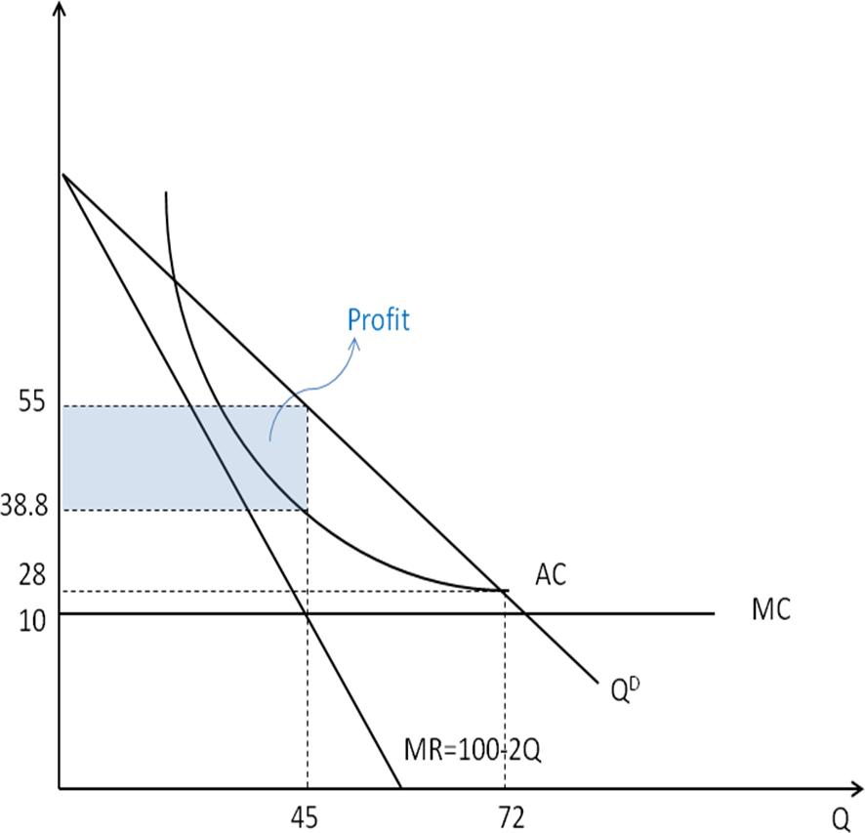

Because of *CenterPoint*'s cost structure it is a monopolist in Blaine. Demand for electricity in Blaine is given by Q = 100- P where Q is again measured in households and P is the price of serving a household.

1. Given its cost structure and the market demand, how many households will *CenterPoint* choose to serve? What price will it charge?

CenterPoint’s Profit = 

MR = MC 

Q=45; P=55

1. In your cost diagram for part (b) illustrate the demand curve and marginal revenue curve for this market. Indicate the profit maximizing price and quantity that you found in part (c). In your diagram for part (b) illustrate the profits of *CenterPoint* at the profit maximizing price and quantity.

See diagram above

The government is aware that as a monopolist *CenterPoint* is earning supernormal profits. A regulator is considering setting a price so that *CenterPoint* earns normal profits. The regulator will choose the lowest price consistent with normal profits.

1. What price should the regulator set to achieve zero profits for *CenterPoint*? What quantity would be traded at this price (assuming that consumers can buy as many units at this price as they would desire).

Let PR be the regulated price set by the regulator

Center Point’s profit = PR(100-PR) -10(100-PR) -1296

To make the profit zero, PR = 28 ; Quantity traded at this price = 100-28 =72

1. At this price would *CenterPoint* be willing to supply all of the units that consumers wish to buy? Briefly explain.

Yes.

1. Illustrate the price and quantity that results in 0 profits in your diagram.

See diagram above

5. The taxation of a monopoly can sometimes produce results different from those that arise in the competitive case. Consider a per unit tax on the monopolist’s good. For every unit sold the monopolist must pay the government $t per unit. In the following assume that the firm has constant marginal costs of production c.

1. Write the first order conditions for the profit maximizing level of output given the tax.

Monopoly profit after the tax :



First order conditions:



1. The first order condition in part (a) establishes an implicit relationship between the quantity chosen by the monopolist and the tax. Use the first order condition to find the derivative of the profit maximizing level quantity with respect to the tax. (Hint: refer to your notes on the incidence of a per unit tax in the competitive case and adapt that analysis to find the derivative of the implicitly defined relationship). Use this answer to write the derivative of the monopoly price with respect to the tax.

Take the derivative of the first order conditions from part (a) with respect to t :



Rearranging to solve for :



1. Suppose that the firm faces a linear demand curve. Use the expression for the derivative in part (b) to determine how much the price rises as a function of the tax. Illustrate your answer in a diagram. Contrast the answer here with the incidence of a tax in the perfectly competitive case.

Linear demand curve : P(Q)= a-bQ ; Marginal revenue : MR(Q) = a-2bQ

Monopoly maximizes profits by MR = MC

a-2bQ =c+t => Q = (a-c-t)/2b

Price at Q :

P(Q) = a-bQ => p(Q) = a-b (a-c-t)/2b => P(Q) = (a+c+t)/2

dP/dt = ½ ; Therefore 50% of the tax is paid by consumers. By contrast, the incidence of the tax on consumers and producers in perfect competition is determined by the relative elasticities of each side of the market.

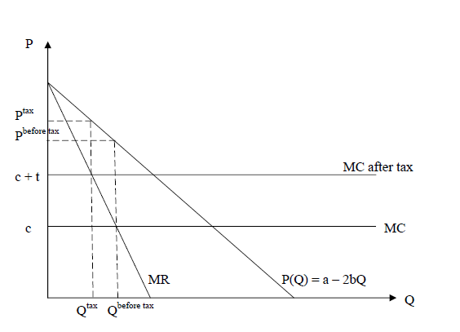

1. Suppose instead that the demand curve in part (c) were a constant elasticity curve. Show that for some elasticities the price would now increase by more than the tax. Was this possible in the perfectly competitive market?

Demand curve with constant elasticities: 

Revenue : 

Marginal revenue : 

Monopoly maximizes profits by MR = MC



Price at Q : , 

A monopolist never operates on the inelastic portion of its demand curve, so . Therefore, , so . That is, the burden of the tax on consumers exceeds 100%.

6. Most four-year colleges in the United States use screening devices to determine how much financial aid to offer to prospective students and thereby increase the schools’ tuition revenue. By offering less financial aid, a college in effect charges a higher tuition price to a student.

Bach College charges $30,000 per year in tuition (this is the price without financial aid). The marginal cost of educating an additional student at Bach is $18,000. There are two types of students that are interested in coming to Bach College. The first group, known as the *Bachmaniacs*, has a demand curve for attending Bach represented by **QD1 = 5000 – (1/6)P** whereP is the actual cost of attending Bach so it is tuition less financial aid. The second group, the *Bachlikers*, has a demand curve for attending Bach represented by **QD2 = 9000 – (1/3)P** where as before P is the actual cost of attending Bach.

1. Suppose that the admissions office of Bach cannot distinguish between those students in group 1 (the *maniacs*) and those in group 2 (the *likers*) and so it must offer the same financial aid package to both. If the admissions office must charge the same actual price to students in both groups then what price will it charge to maximize the profits of Bach College? How much financial aid is offered to each student? How many students in each group will be admitted?

When the seller cannot distinguish different groups of buyers, he/she is facing only one demand function:



=> To solve for the marginal revenue, we have to convert it back to the inverse demand function:

P = 28,000-2QD

Total Revenue = PQ = (28,000 - 2Q)Q = 28,000Q - 2Q2

To maximize the profit, the college offers admission to the level where their MR = MC.

28,000 - 4Q = 18,000 => Q = 2,500 => P = 23,000 , and each student gets $7,000 financial aid.



A clever dean in the admissions department realizes that there may be a way to distinguish between the two types of prospective students. By offering to all students the opportunity to visit and tour the campus the dean claims that they will be able to sort the students

1. Briefly explain why a firm would like to sort its customers into different groups. What criterion does a firm use to sort individuals? How might the campus visit sort students into their two distinct markets?

By sorting customers into different groups the firm can gather more profits from each group thereby increase their total profits. Firms usually look at the customers' willingness to pay, and it can be revealed by age, income, or other criteria. The clever dean in this question simply assumes the "manics" would love to visit the school in advance to experience the environment and make future plans, while those "likers" are not that enthusiastic and mostly won't bother to visit the school.

1. Assuming that the dean’s scheme works so that all of the *maniacs* visit the campus and none of the *likers* visit the campus then what price will Bach charge students in each of the two groups? How much financial aid will the college offer to each of the two groups? How many *maniacs* will attend Bach? How many of the *likers* will attend Bach?

Once the school can distinguish two groups, they can charge different prices on them.

For the first group:

P1 = 30,000 - 6Q1 => Total Revenue = P1Ql = (30,000 - 6 Ql) Ql,

MR = 30,000 -12 Ql .

MR = MC => 30,000 - 12 Ql = 18,000 => Ql = 1,000, P1 = 24,000

For the second group:

P2 = 27,000 - 3Q2 => Total Revenue = P2 Q2 = (27,000 - 3 Q2 ) Q2,

MR = 27,000 - 6 Q2 .

# MR = MC => 27,000 - 6 Q2 = 18,000 => Q2 = 1,500, P2 = 22,500

The profit school can gather from this program is:

$24,000*1,000 + $22,500*1500 - $18,000*2500 = $12,750,000

The profit school can gather without recognizing two different groups of students: $23,000*2500 - $18,000*2500 = $12,500,000

Price discrimination can earn the school more money.

7. The *Soybean Syndicate* is the unique supplier of soybeans in Bali (so it is a monopolist in Bali). The inverse market demand for soybeans in Bali is given by **P(Q) = 1000 – 2Q** where Q is measured in tons per day and P is measured in dollars per ton. The *Soybean Syndicate’s* cost is given by **C(Q) =.5Q2**.

1. How many tons of soybeans will the *Soybean Syndicate* sell in Bali? At what price will it sell soybeans? Illustrate your answer. Be sure to indicate in your diagram the total quantity sold and the price at which it is sold.

Soybean Syndicate’s profit = (1000-2Q)Q-0.5Q2

MR = 1000-4Q ; MC = Q ;

MR = MC => QM=200; PM=600;

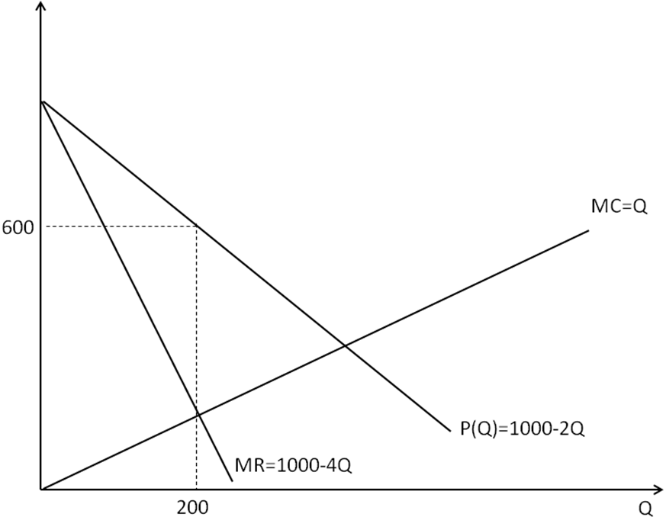

Soybeans are also sold on the world market which is perfectly competitive. The current world market price is $400 per ton. However, to sell on the world market the *Syndicate* has to pay shipping costs equal to $60 per ton.

1. Why would the *Syndicate* be willing to spend $60 to ship its soybeans to be sold at a lower price? Briefly explain your answer.

Marginal revenue to sell soybeans to the world market = 400-60 =340

Marginal cost to produce Qbali + Qexport

*Soybean Syndicate* is willing to sell its soybeans to the world market if MR>MC

1. At the world price of $400 and shipping costs of $60 how many tons will the *Syndicate* sell on the world market? How many tons will it sell in Bali? What will be the price of soybeans in Bali? Illustrate your answer in the diagram.

Profit = (1000-2Qbali)Qbail + (400-60)Qexport – 0.5(Qbali+Qexport)2

MRbali = 1000-4Qbali = Qbali + Qexport (= MC)

MRexport = 340 = Qbali + Qexport (= MC)

* Qbali = 165 ; Qexport = 175 ;
* Pbali = 1000-2*165 = 670;

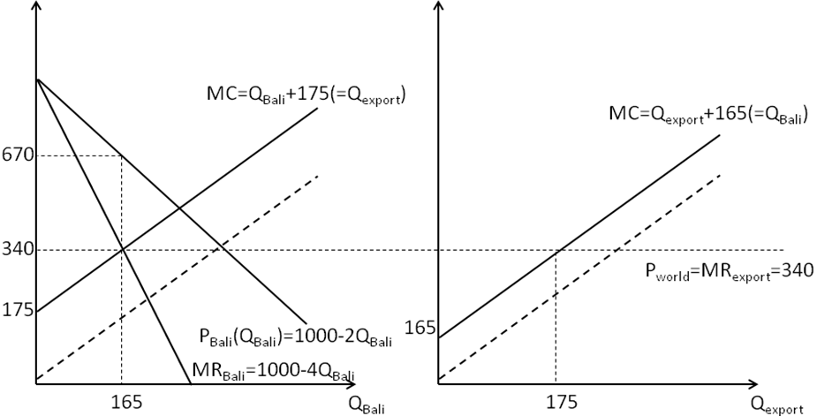

1. If the world price remains constant at $400 per ton then what is the highest shipping cost at which the *Syndicate* would be willing to sell soybeans on the world market?

Let S be shipping cost.

Profit = (1000-2Qbali)Qbail + (400-S)Qexport – 0.5(Qbali+Qexport)2

MRbali = 1000-4Qbali = Qbali + Qexport (= MC)

MRexport = 400-S = Qbali + Qexport (= MC)

* Qbali = 150+S/4 ; Qexport = 250-(5/4)S ;

Therefore, Qexport ≥0 if S≤200

At S =200, Qbali = 150+200/4 =200 ; Qexport = 250-(5/4)*200 = 0 ; Pbali = 1000-2*200 = 600; (same as in (a) )